System Design/ Architecture Overview

  - Introduction

Laravel 9 is the framework chosen for this project. It is an open-source PHP framework that provides an array of features that make developing a web application smoother. It follows the model-view-controller architecture pattern which is common in web and mobile application development.

Features included in Laravel are Breeze for implementing authentication, and Blade as the templating engine.

  - Model View Controller

This architectural patter separates the application into three main components that interact with each other and handle their own specific aspects of the application. How this will work in this project's application is that the end user will request a page, their profile page for example, this request is handled by the ‘user’ controller, assuming the user is already logged in. The controller then sends the request to the 'user’ model which retrieves the data from the database. This data is sent back to the controller and is then sent to the ‘profile’ view, where the data is rendered to the user.

  - User Authentication

Breeze is an authentication scaffolding package that is used with Laravel to provide user login, registration, password reset, email verification, and password confirmation. This package allows for users to register themselves and easily login. This authentication is used in the application to prevent users from viewing pages they should not have access to, such as edit pages for other users’ profile. The middleware A profile page is included when Breeze is install so that users can easily edit their information. This profile page has been re-designed to include all profile elements needed for this web application, as discuss in earlier sections.

  - Routing

The routes defined in this web application are the dashboard, profile view with CRUD functions, partner search and goal's view with CRUD functions. The end user, not an admin but basic user, who is trying to access their profile will click on the profile navigation item and be sent to the URL ‘user/profile’. The route for this URL is mapped to the user.profile resource controller which then requests the relevant data through the ‘user’ model.

  - Templating

Blade is the templating engine included with Laravel and is a PHP based engine which allows developers to use plain PHP code, unlike some other templating engines. Blade is used for all views within the application as it can dynamically display any data that is requested from the server. Since Blade uses PHP, developers can use PHP code within the views which allows them to, for example, loop through and display data such as user profiles, in the application.
Blade was used in conjunction with Bootstrap to style the application. In the ‘Profile’ view, a blade template was used to create the layout and design of the page and then for the relevant user data to be displayed, changing when different profiles were selected. Wrapping the data needing to be displayed in curly braces lets the data variable be passed from the database, though the model, the controller and then to the view to be rendered. Blade template components were used throughout the application for elements such as the navigation bar and forms. The advantage of using Blade templates is that a change to the design or layout needs only to be made in the template file and not in each instance that template is used and is a much better way to manage code.

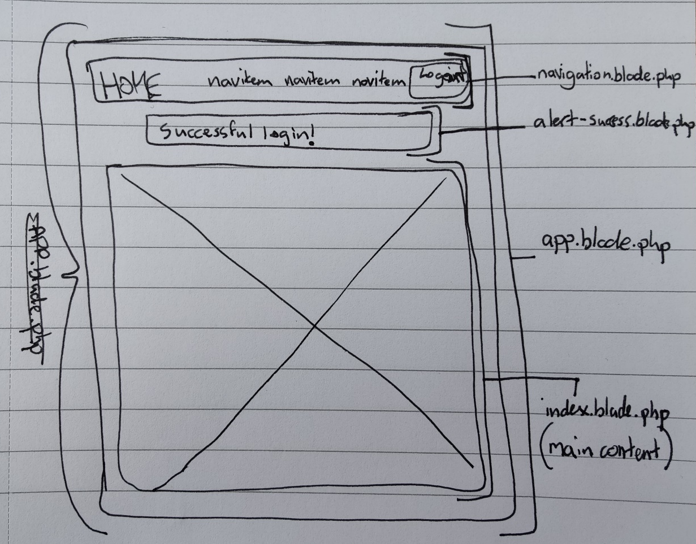
Figure 26 - Blade template

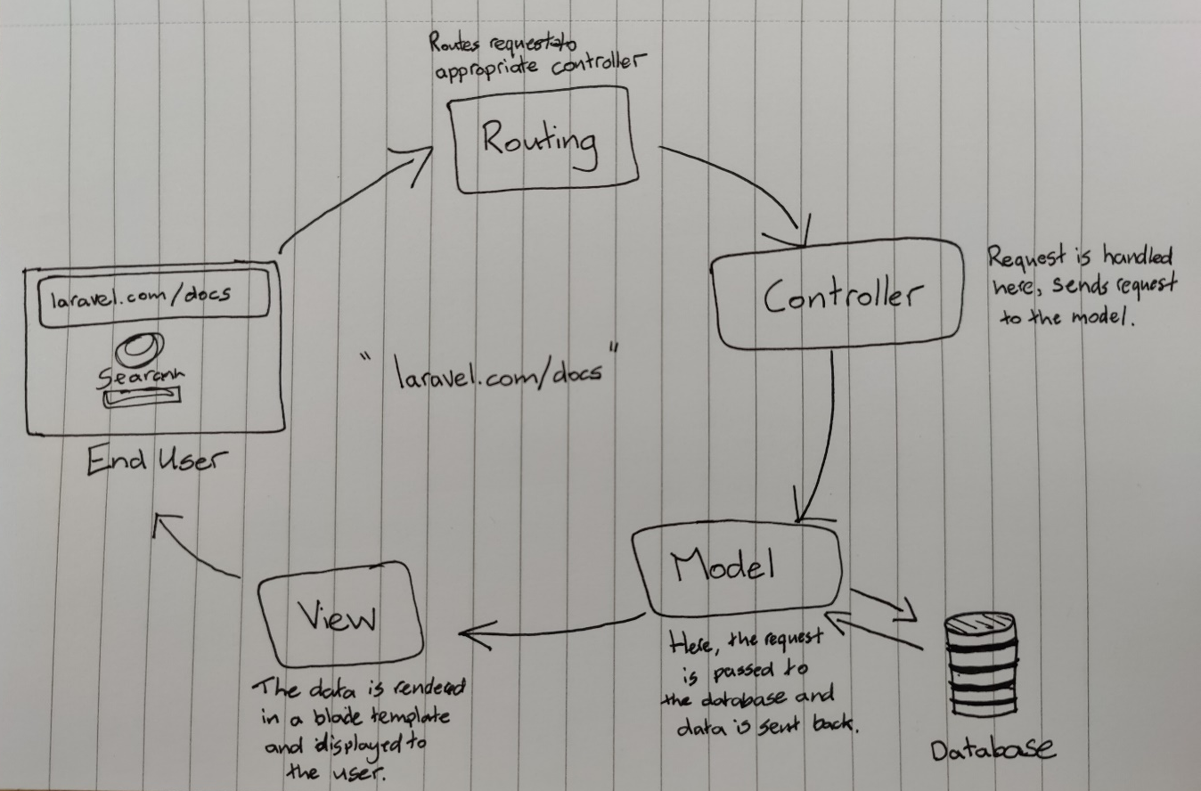
Figure 27 - Diagram of routing, controller, model and view process

